Web VTS Installation Guide

System Requirements

- Supported Operating Systems: Windows Server 2008 - Windows Server 2016
- Minimum 3 GHz 64-bit Intel or AMD processor (4 GHz or faster is recommended)
- Minimum of 8 GB of RAM (16 GB or more is recommended)
- 500 GB of available hard disk space
- Internet Information Services 7.0 - 8.5 (IIS 7.0 - 8.5)
- .NET Framework Version 4.6
- Microsoft SQL Server 2008-2016 or SQL Server 2008-2016 Express Edition

Installation Sequence

The following software installation sequence is a general guideline. Unless otherwise instructed by SiiTech technical support, please follow these steps to ensure successful installation of your Web VTS solution.

- Install Internet Information Services.
See the “Installing IIS 7.5 on Windows Server 2008 R2.doc” document for Window Server 2008 R2.
See the “Installing IIS 8.5 on Windows Server 2012 R2.doc” document for Windows Server 2012/2012 R2.

- Install Download and install .NET Framework 4.6.2
https://www.microsoft.com/en-us/download/details.aspx?id=53344
- Install MS SQL Server and MS SQL Server Management Studio.
See the “Installing MS SQL Server.doc” document for more information.

- Install AIS Server.
- Install Web VTS.

Installing Web VTS

You must login as Administrator on the computer to install Web VTS.

AIS Server must be already installed on the computer.

- Double click on the Web VTS setup file (WebVTSxxxxxxSetup_x_xx_xx.msi). In the Welcome dialog box, click Next.

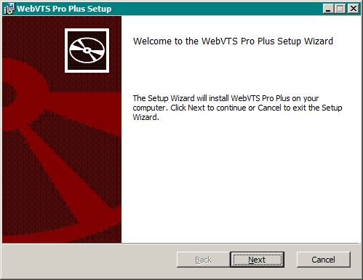

- You will be presented with the License Agreement. If you agree to the terms of this license agreement, select the I accept the terms in the License Agreement check box and click Next. If you do not agree to the terms of this license agreement click Cancel so that the installer does not continue. You will be unable to install this software application.

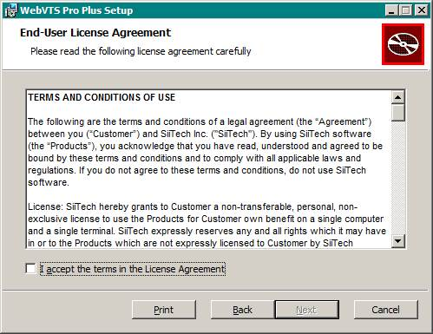

- The installer will install the Web VTS files into a default virtual directory. If you wish to install Web VTS to the default virtual directory, click Next. If you wish to have Web VTS installed to a different virtual directory, enter a name for the virtual directory. When you have selected the virtual directory, click Next at the Select Installation Address dialog box.

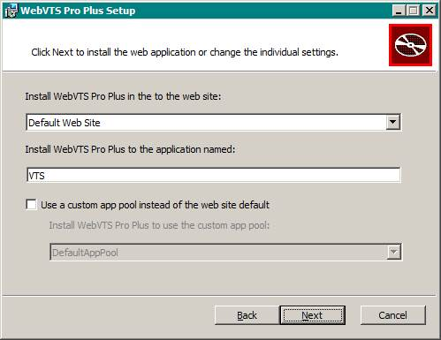

- Click Next at the Ready to install dialog box to begin copying the necessary Web VTS files to your computer. The installer will report its process as it installs the files.

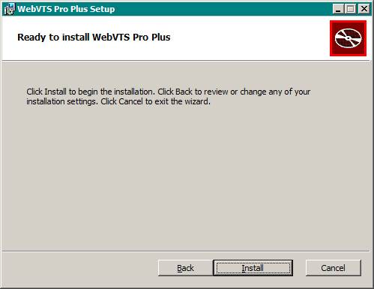

- You will be presented with the Web VTS Database dialog box. At this step you have to create Web VTS database.

To create Web VTS database:

  - In the Server name list box, select or type the name or address of the SQL Server instance on which you want to create the database.
- Enter "." to use your local SQL Server
- Enter ".\SQLEXPESS" to use your local SQL Server Express
- Enter a computer name or IP address to use SQL Server installed on that computer
  - In the Authentication list box select SQL Server authentication mode.
  - If you selected SQL Server Authentication, in the User name box, type the name of the SQL Server account that you want to use to create the new database.
  - If you selected SQL Server Authentication, in the Password box, type the password for the account.
  - Click Create/update Web VTS database.

After the database setup is completed, click Next.

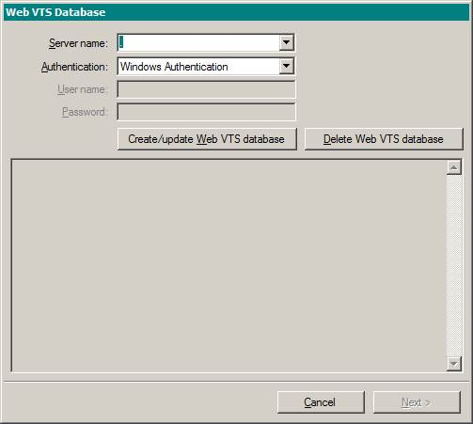

- You will be notified when installation has completed. Click Finish to complete the installation.

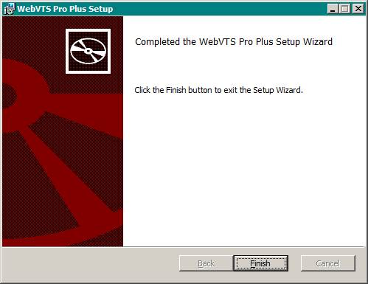

- To launch Web VTS Pro Plus:
- Open your web browser and enter http://localhost/vts in URL address box;
- Log in to the application using ”admin” as user name and "1234" as password.
- To launch Web VTS Pro:
- Open your web browser and enter http://localhost/vtspro in URL address box;
- Log in to the application using ”admin” as user name and "1234" as password.

